

Four Square World Championship returns for 20th year in Bridgton

The 20th annual Four Square World Championship took place in Bridgton, with people coming from across the country to play the classic childhood game.


The 20th annual Four Square World Championship were held in Bridgton on Saturday, April 12. The event, which saw almost 100 players from as far afield as Montana and North Carolina come to the Lakes Region to compete in the classic playground game, has been held in Bridgton for two decades. About 50 spectators also came to the Bridgton Town Hall to cheer on the players, the most in the history of the competition.
Peter Lowell, lead organizer and founder of the championship, said that, in previous years, they had gotten players from foreign countries such as Canada, Germany, and England.
According to the competition’s website, the event was divided into four divisions, one each for men and women age 15 and older, as well as boys and girls age 14 and younger. Two fun-filled rounds are played by everyone as an “open-scoring round” separated by divisions. The top 8-12 players per division move on to the coveted championship round which display the best-of-the-best. Eventually, the final two compete in a showdown until the last standing champion is crowned.
The children’s division was won by Oscar Houghton on the boys’ side, and Isabella Gomez-Mancia for the girls. Both students came from Whitefield Elementary School in Lincoln County, where Lowell said that students had been practicing all year.
In the women’s division, Brittany Dunay, a six-time champion from New York, won the junior trophy, while Anne Lowell of Maine won the senior trophy. The junior men’s winner was Joseph Henson, while the senior men’s champion was Eric Costanza of Northbridge, Massachusetts.
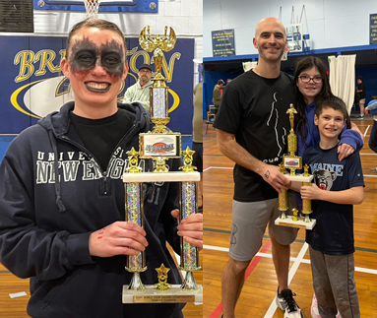
Costanza, a three-time reigning champion, nicknamed “The Assassin,” due to his under-cover style of getting competitors out said his fascination with four square dated back to his childhood, when he would play with his brother and friends.
‘The Assassin’ won at his first world championship in 2023, and he has been going up to Bridgton with his family every year since. Costanza said he did not know how he would match up against players from across the United States and beyond,
especially with most half his age, and described his first win as very humbling. He said it was a great honor to say that he was a world champion at something, noting that he has become something of a local figure in his hometown. Beyond his personal achievements, Costanza has made an incredible impact on youth sports in his community. He was instrumental in creating a new Four Square court, ‘Costanza Court’, named in his honor, and runs summer camps to introduce children to the game, encouraging outdoor activity, exercise, and social connection. His dedication ensures that kids have access to structured, engaging play while fostering teamwork, fitness, and a lifelong appreciation for sports.
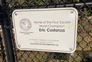
He also is doing his due diligence in growing the game by tri-hosting “The Four Square Show” featured online alongside fellow competitors, Daniel Richmond, from Houston, Texas, and Joe Costa, from Maine. Pertaining to the world championships, Costanza says, “It’s just become a real special and magical, type of event that brings people together from all over the place to enjoy the love of four square”.

